BLANK
RESTORING SHROPSHIRE’S VERGES: Case Studies
SITE NAME include grid reference https://gridreferencefinder.com/
Establishment of a wildflower verge
Partners/Funders: Restoring Shropshire’s Verges Project (RSVP) + other?
Costs:
- Volunteer time number of hours
- Any funding costs
- Any free contributions seeds/plants
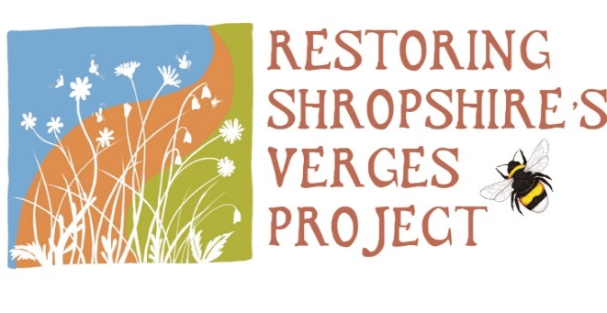
Twitter and Facebook @ShropsVerge
Contact:
shropsverge@gmail.com
……………………………………………………………………………

RESTORING SHROPSHIRE’S VERGES PROJECT :
Description of project and how it developed
Photographs
Further work
Add any logo’s of supporter organisations in footer

